bora shiva

[Company name]  [Company address]

sonarqube

* Download SonarQube / Sonar scanner <https://www.sonarqube.org/downloads/>

<https://docs.sonarqube.org/latest/analysis/scan/sonarscanner/>

* Unzip sonar scanner -> open sonar scanner folder -> conf -> sonar-scanner.properties -> uncomment sonar.host.url=http://localhost:9000 (windows)

Ec2 ipv4:9000 (aws)

* Unzip sonarqube -> open sonarqube folder -> open bin folder -> choose os ex: windows-x86-64 -> run StartSonar.bat file (linux-> sh sonar.sh start)
* Run <http://localhost:9000/> (default port 9000) on your browser
* Default user name and password is admin/admin
* **Sonarqube integrate with Jenkins**
* **Open Jenkins ex:** <http://localhost:8080/> (d)
* Manage Jenkins -> manage plugins -> available -> sonar scanner (install without restart)
* Manage Jenkins -> global tool configuration -> sonarqube scanner 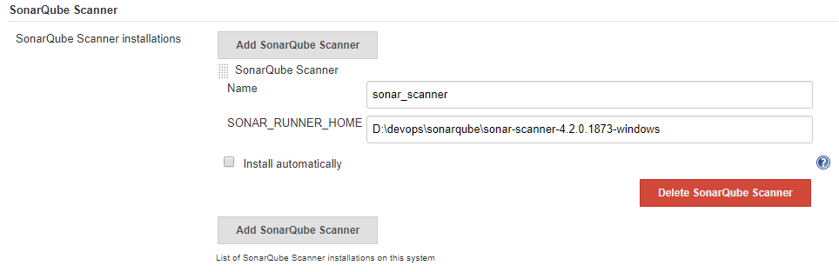
* Manage Jenkins -> configure system -> sonarqube servers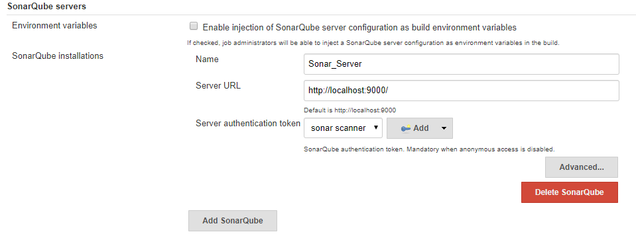

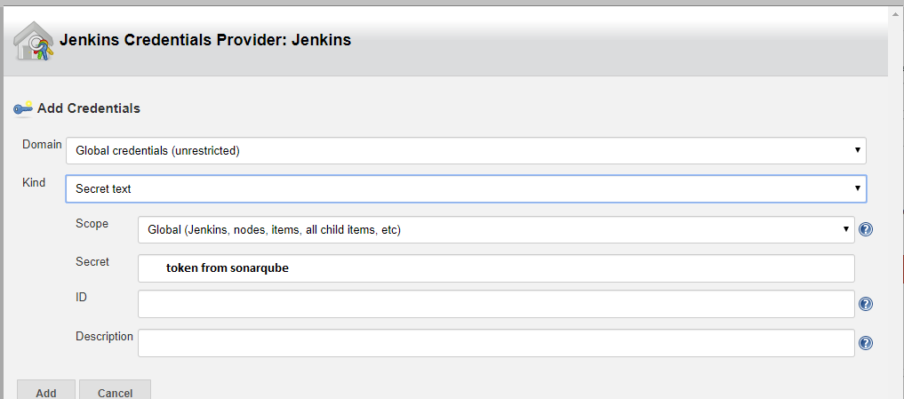

* Open SonarQube -> edit profile -> security -> generate token 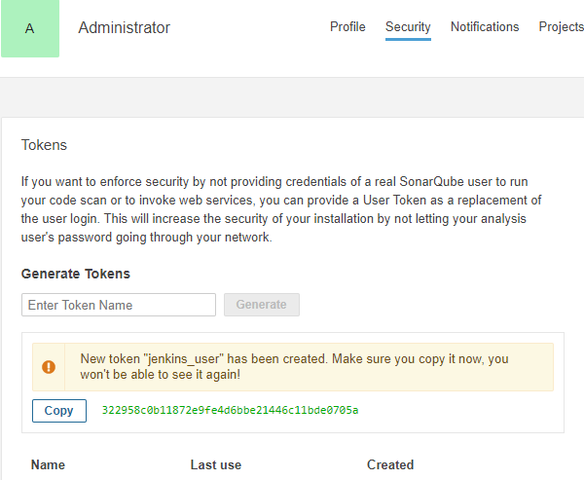
* Create freestyle project

sonar.projectKey=abbott

sonar.projectName=abbott

sonar.projectVersion=1.0

sonar.sources=D:/devops/jio_store/src

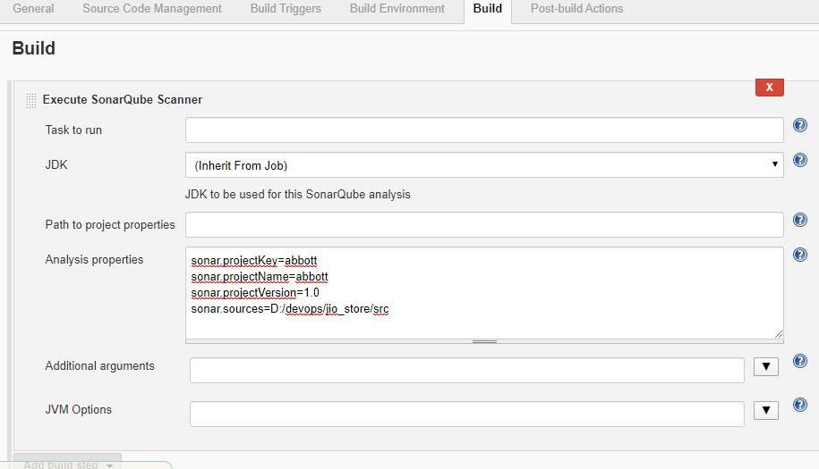

* Build now